Kyle Bielby EE 408 Lab 3

Part 1

1a. See Photo below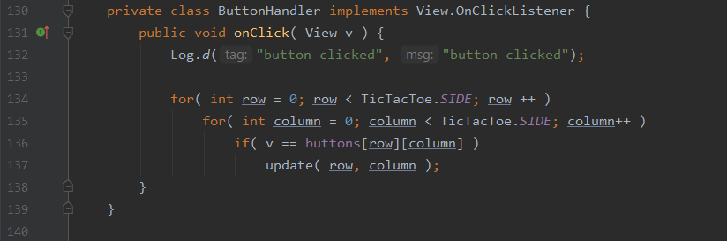

1b. When a square is clicked, the “onClick” function in the image above is called, and the function uses a nested for loop structure to index through a two-dimensional array containing the id’s of the buttons. If the button matches the one passed to the onClick function, then the function calls method update and passes the function the row and column number of the tic-tac-toe grid. The function then checks which player’s turn it is. If the player is player number 1 then an X is placed in the corresponding grid section by calling the setText function. The setText function then changes the text stored in the text view placed inside the grid.

1c. After a game is completed, a dialog window appears prompting the user with the option to play again. The PlayDialog class instance is called. The onClick method inside this class then is called and handles the click event actions. The id of the button is passed to the onClick function. If the id represents the yes option (-1) then the game and the buttons are reset. On the other hand, if the id represents the no option (-2) then program finishes with the call MainActivity.this.finish().

1d. Line 151 with the call to MainAcitivity.this.finish().

1e. ButtonHandler and PlayDialog

Part 2

2a. 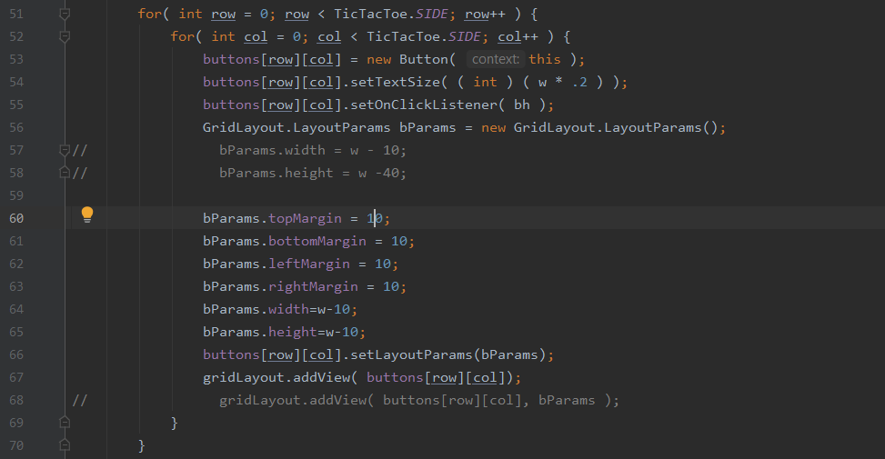

2b. 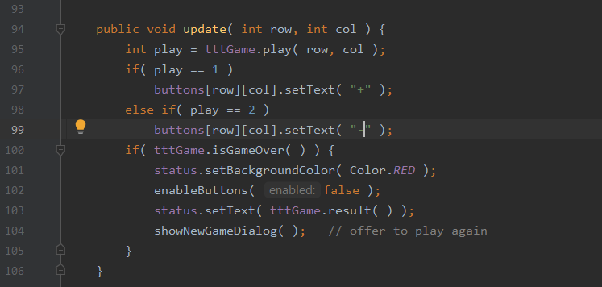

2c. 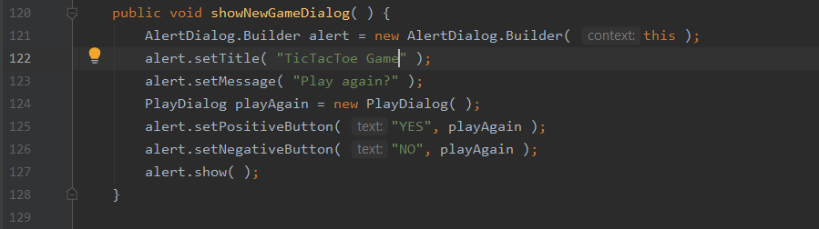

2d. 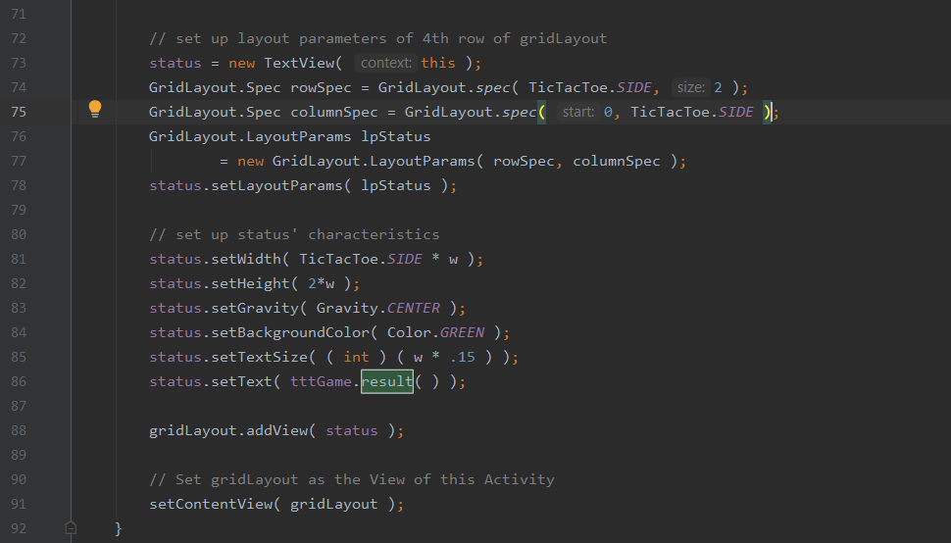

2e. 